User Manual: Contact Phones, Addresses, and Notes

| july-20 |

**Document Overview**

**Documentation Goals**

This documentation is intended to provide instruction for ***Viewing and Adding Contact Phone Numbers, Notes, and Addresses****.*

**Documentation Disclaimers**

* Teach a user how to utilize Customer and Vendor contact and address information.
* Provide instructions for creating Customer and Vendor Contact Phone Numbers, Contact Notes, and Address Information.

**Table of Contents**

**Overview** 3

**Customers** 4

Browse Customers 4

Phone Info 5

Browse Phone 5

View Phone 6

Add/Update Phone – Manual Input 7

Add/Update Phone Field Definitions 8

Add/Update Phone – Import from Customer Contacts 9

Email Notification System Options 10

Customer Notes – Browse 11

Customer Notes – View 12

Add/Update Notes 13

Add/Update Notes Field Definitions 13

**Vendors** 14

Browse Vendors 14

Phone Info 15

Browse Phone 15

View Phone 16

Add/Update Phone – Manual Input 17

Add/Update Phone Field Definitions 18

Add/Update Phone – Import from Customer Contacts 19

Email Notification System Options 20

Customer Notes – Browse 21

Add/Update Notes 23

Add/Update Notes Field Definitions 23

Addresses 24

Browse Address 24

Add/Update Address 26

Add/Update Address Field Definitions 26

# **Overview**

The Customer and Vendor files contain icons that provide the user with information for an unlimited number of contacts within a specific Company or Vendor.

Please Note: There are three types of codes that a user must add before adding new contacts.

#### Email Codes

These allow adding contacts for specific business forms and specific reports. When sending emails, the *“Send To”* will transfer by form or report, hence a lookup is not required, thus saving the user some time.

#### Title Codes

These are used in the Customer and Vendor file via the ***“F10”*** Phone Book Icon. The Title Code imports from the *Codes File*, and emails may be sent to multiple contacts by specific forms.

Multiple contacts can get a quote form. Other contacts will receive invoices or statements, and some contacts may be assigned to receive customer inventory reports.

#### Zip Codes

Zip codes defined here may be added to the contacts in the Customer and Vendor File.

# **Customers**

The user can look up Customer phone information from the *“Customer File Maintenance’* screen.

### Browse Customers

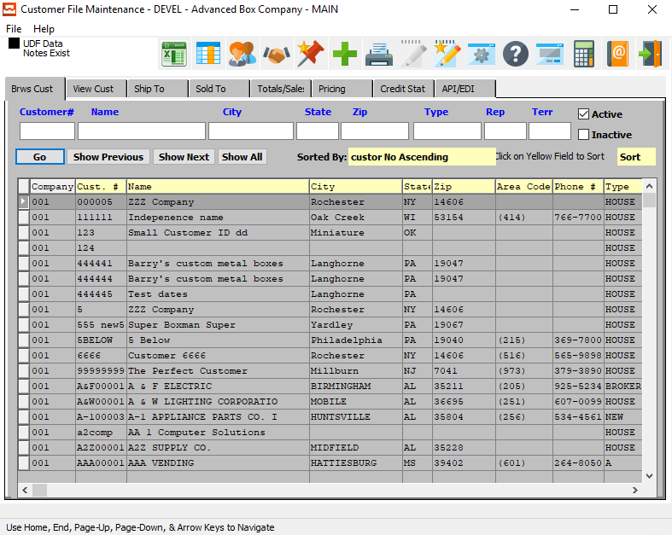

In order to view phone information for a specific customer, the desired customer must be selected within the list of all available customers. The user may search for a specific customer, or narrow down the browse list, by using the search fields located along the top of the page.

In order to select a specific customer within the list to view detailed information for, the user must ensure that it is highlighted within the list. In order to highlight a customer, the user may click on their desired customer.

## Phone Info

To view phone information for the selected customer, the user may now click on the ***“@ Pictured Address Book”*** at the top of the screen.

### Browse Phone

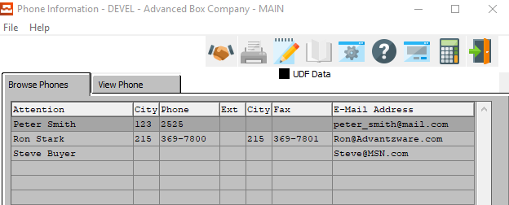

The Browse Phone screen will show the user all of the available contacts for the selected customer.

In order to view detailed information for a specific contact, the desired contact must be selected within the list of all available contacts. The user may search for a specific contact, or narrow down the browse list, by using the search field located at the bottom of the page.

In order to select a specific contact within the list to view detailed information for, the user must ensure that it is highlighted within the list. In order to highlight a contact, the user may click on their desired contact.

#### View Phone

Once the user has highlighted their desired contact to view detailed information for, they may click on the ***“View Phone”*** tab at the top of the screen. This tab allows the user to view detailed information, as well as update and add contacts.

#### Open Notes

Once the user has highlighted their desired contact to view detailed information for, they may click on the ***“Paper and Pencil Icon”*** button at the top of the screen. This button opens the Notes section for the highlighted contact, showing the user any notes specifically attached to that contact.

This will also allow the user to update and add notes for the designated contact.

### View Phone

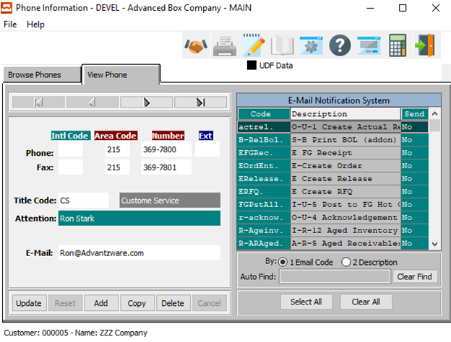

The ***“View Phone”*** screen shows the user detailed information about the selected Contact. In this screen, the user can update information about the current contact, update the current contact’s selected email notifications, or add a new contact.

#### UPDATE

Click the ***“Update”*** button to update the current Contact’s information.

#### ADD

Click the ***“Add”*** button to add a new Contact for this customer. If the user has chosen to ***“Add”*** a new Contact, the system will ask if the user wishes to import from the Customer Contact system.

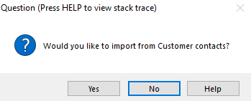

If the user chooses ***“Yes”***, the system will open the *“Customer Contacts Multi-Selector’* screen.

If the user chooses ***“No”***, the user will be allowed to manually enter all contact information into the screen.

#### COPY

Click the ***“Copy”*** button to copy information from the currently selected contact.

#### DELETE

Click the ***“Delete”*** button to delete the currently selected contact.

#### NEXT

Press ***"N"*** (Next) to find next Contact to view or modify. Alternatively, press the ***“Right Arrow”*** on the screen.

#### PREVIOUS

Press ***"P"*** (Previous) to find previous Contact to view or modify. Alternatively, press the ***“Left Arrow”*** on the screen.

### Add/Update Phone – Manual Input

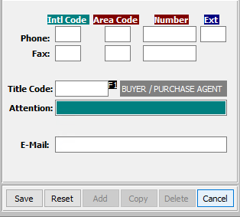

#### SAVE

Click the “***Save***” button to save the current Contact.

#### RESET

Click the “***Reset***” button to reset all changes to the Contact.

#### CANCEL

Click the “***Cancel***” button to cancel the Contact without saving changes.

### Add/Update Phone Field Definitions

#### International Code - Phone

Enter the International Code for this contact’s phone number.

#### Area Code - Phone

Enter the Area Code for this contact’s phone number.

#### Phone Number

Enter this contact’s phone number.

#### Phone Extension

Enter this contact’s phone extension code.

#### International Code – Fax

Enter the International Code for this contact’s fax number.

#### Area Code – Fax

Enter the Area Code for this contact’s fax number.

#### Fax Number

Enter this contact’s fax number.

#### Title Code

Enter this contact’s Title Code. Alternatively, the user can press the ***“F1”*** key to choose a Title Code from a list of available codes.

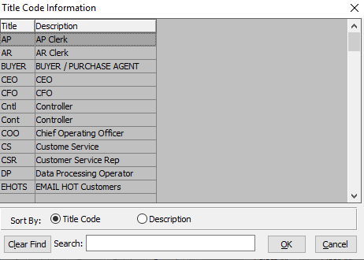

#### Attention

Enter the Contact’s Name.

#### E-Mail

Enter the e-mail address for this contact.

### Add/Update Phone – Import from Customer Contacts

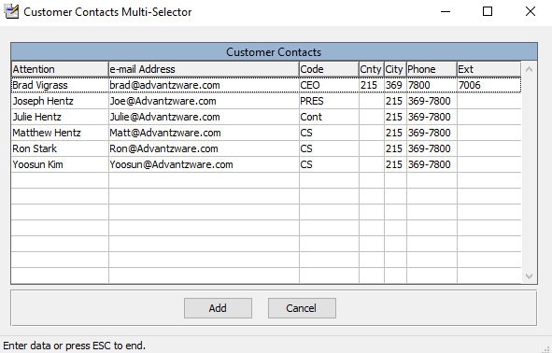

The user may choose a contact to add to this customer from a list of available contacts in the system. In order to select a specific contact to add, the user must ensure that it is highlighted within the list. In order to highlight a contact, the user may click on their desired contact.

#### ADD

Once the desired contact has been highlighted within the list, t he user may click the ***“Add”*** button to add the contact to the Customer list of contacts.

#### CANCEL

If the user does not see a contact that they wish to add, they may click the ***“Cancel”*** button cancel adding a new contact to the Customer Contact list.

### Email Notification System Options

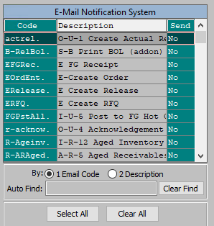

The *‘E-Mail Notification System’* allows the user to quickly choose which e-mails this Contact will receive from the Advantzware system. Contacts will only receive system emails that have their *“Send”* column set to ***“Yes”***.

In order to set the Contact up for a specific email notification, the user can search for their desired Email Code narrow down the browse list, by using the search field located at the bottom of the page.

In order to set a specific contact within the list to a ***“Yes”*** send option, the user must double-click the desired email code. This will set the email send option to ***“Yes”*** if it is currently ***“No”***, opting the Contact in for this specific email. Alternatively, double-clicking an email that currently has a send option of ***“Yes”*** will set it to ***“No”***, thus opting the contact out of receiving the selected email.

#### SELECT ALL

Clicking the ***“Select All”*** button will opt the user into receiving all the system emails currently available, setting all the Send Options to ***“Yes”***.

#### CLEAR ALL

Clicking the ***“Clear All”*** button will opt the user out of receiving all the system emails currently available, setting all the Send Options to ***“No”***.

### Customer Notes – Browse

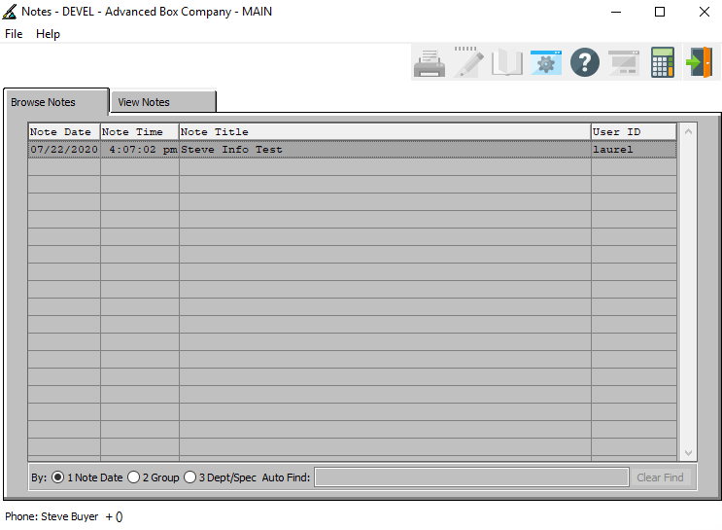

The *“Contact Notes”* screen allows a user to create an unlimited number of notes pertaining to the currently selected Contact. It keeps track of the note’s date and time so that the user can clean up old notes as necessary.

The *“Browse Notes”* screen shows the user the titles of all of the available notes for the currently selected contact. In order to view detailed notes for a specific contact, the desired note must be selected within the list of all available notes. The user may search for a specific note, or narrow down the browse list, by using the search field located at the bottom of the page.

In order to select a specific note within the list to view detailed information for, the user must ensure that it is highlighted within the list. In order to highlight a note, the user may click on their desired note.

### Customer Notes – View

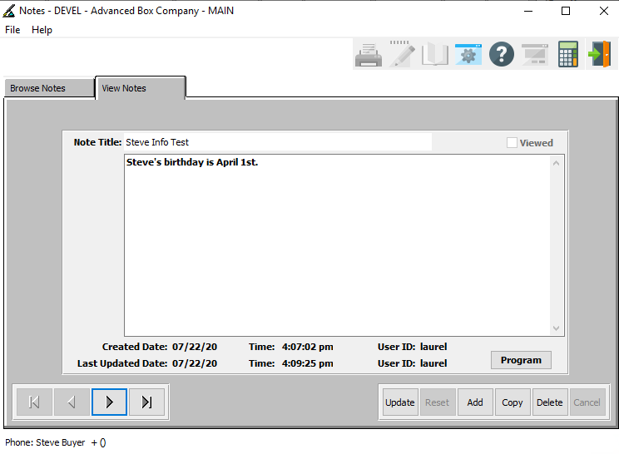

#### UPDATE

Click the ***“Update”*** button to update the currently selected Contact Note.

#### ADD

Click the ***“Add”*** button to add a new note for the current Contact Note.

#### COPY

Click the ***“Copy”*** button to copy information from the currently selected Contact Note.

#### DELETE

Click the ***“Delete”*** button to delete the currently selected Contact Note.

#### NEXT

Press ***"N"*** (Next) to find next Contact Note to view or modify. Alternatively, press the ***“Right Arrow”*** on the screen.

#### PREVIOUS

Press ***"P"*** (Previous) to find previous Contact Note to view or modify. Alternatively, press the ***“Left Arrow”*** on the screen.

### Add/Update Notes

#### SAVE

Click the “***Save***” button to save the current Contact Note.

#### RESET

Click the “***Reset***” button to reset all changes to the Contact Note.

#### CANCEL

Click the “***Cancel***” button to cancel the Contact Note without saving changes.

### Add/Update Notes Field Definitions

#### Note Title

The user may enter a short description of this note’s contents in this field.

#### Notes

The user may enter all the notes that they wish in this field.

# **Vendors**

The user can look up Vendor phone and address information from the *“Vendors”* screen.

### Browse Vendors

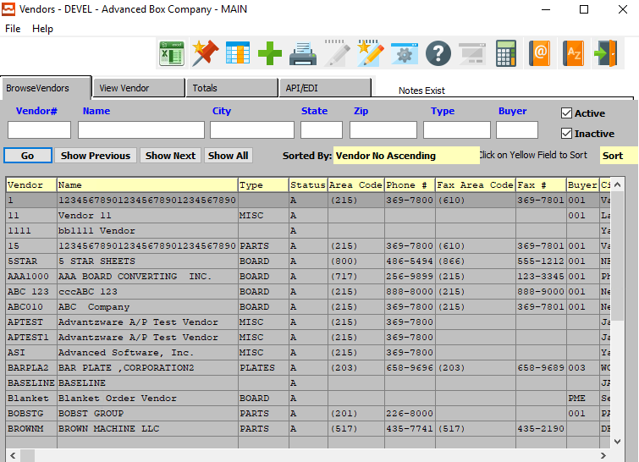

In order to view phone and address information for a specific Vendor, the desired Vendor must be selected within the list of all available Vendors. The user may search for a specific Vendor, or narrow down the browse list, by using the search fields located along the top of the page.

In order to select a specific Vendor within the list to view detailed information for, the user must ensure that it is highlighted within the list. In order to highlight a Vendor, the user may click on their desired Vendor.

## Phone Info

To view phone information for the selected Vendor, the user may now click on the ***“@ Pictured Address Book”*** at the top of the screen.

### Browse Phone

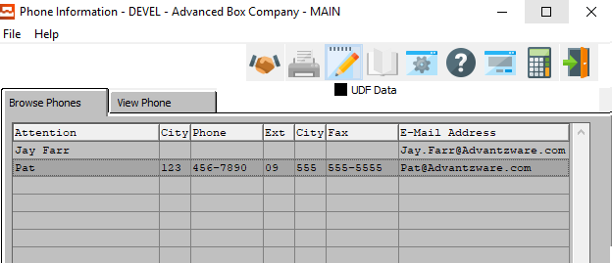

The Browse Phone screen will show the user all of the available contacts for the selected Vendor.

In order to view detailed information for a specific contact, the desired contact must be selected within the list of all available contacts. The user may search for a specific contact, or narrow down the browse list, by using the search field located at the bottom of the page.

In order to select a specific contact within the list to view detailed information for, the user must ensure that it is highlighted within the list. In order to highlight a contact, the user may click on their desired contact.

#### View Phone

Once the user has highlighted their desired contact to view detailed information for, they may click on the ***“View Phone”*** tab at the top of the screen. This tab allows the user to view detailed information, as well as update and add contacts.

#### Open Notes

Once the user has highlighted their desired contact to view detailed information for, they may click on the ***“Paper and Pencil Icon”*** button at the top of the screen. This button opens the Notes section for the highlighted contact, showing the user any notes specifically attached to that contact.

This will also allow the user to update and add notes for the designated contact.

### View Phone

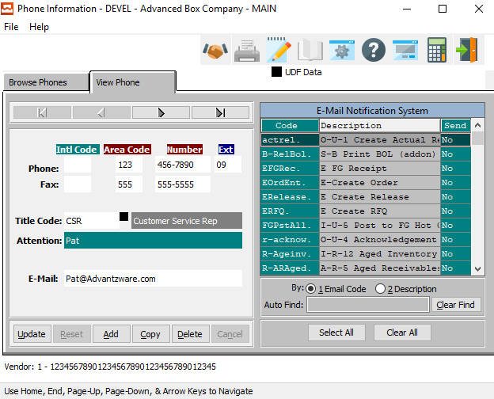

The ***“View Phone”*** screen shows the user detailed information about the selected Contact. In this screen, the user can update information about the current contact, update the current contact’s selected email notifications, or add a new contact.

#### UPDATE

Click the ***“Update”*** button to update the current Contact’s information.

#### ADD

Click the ***“Add”*** button to add a new Contact for this customer. If the user has chosen to ***“Add”*** a new Contact, the system will ask if the user wishes to import from the Customer Contact system.



If the user chooses ***“Yes”***, the system will open the *“Customer Contacts Multi-Selector’* screen.

If the user chooses ***“No”***, the user will be allowed to manually enter all contact information into the screen.

#### COPY

Click the ***“Copy”*** button to copy information from the currently selected contact.

#### DELETE

Click the ***“Delete”*** button to delete the currently selected contact.

#### NEXT

Press ***"N"*** (Next) to find next Contact to view or modify. Alternatively, press the ***“Right Arrow”*** on the screen.

#### PREVIOUS

Press ***"P"*** (Previous) to find previous Contact to view or modify. Alternatively, press the ***“Left Arrow”*** on the screen.

### Add/Update Phone – Manual Input

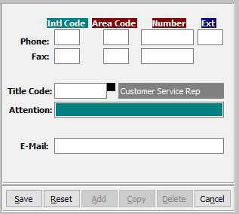

#### SAVE

Click the “***Save***” button to save the current Contact.

#### RESET

Click the “***Reset***” button to reset all changes to the Contact.

#### CANCEL

Click the “***Cancel***” button to cancel the Contact without saving changes.

### Add/Update Phone Field Definitions

#### International Code - Phone

Enter the International Code for this contact’s phone number.

#### Area Code - Phone

Enter the Area Code for this contact’s phone number.

#### Phone Number

Enter this contact’s phone number.

#### Phone Extension

Enter this contact’s phone extension code.

#### International Code – Fax

Enter the International Code for this contact’s fax number.

#### Area Code – Fax

Enter the Area Code for this contact’s fax number.

#### Fax Number

Enter this contact’s fax number.

#### Title Code

Enter this contact’s Title Code. Alternatively, the user can press the ***“F1”*** key to choose a Title Code from a list of available codes.



#### Attention

Enter the Contact’s Name.

#### E-Mail

Enter the e-mail address for this contact.

### Add/Update Phone – Import from Customer Contacts



The user may choose a contact to add to this customer from a list of available contacts in the system. In order to select a specific contact to add, the user must ensure that it is highlighted within the list. In order to highlight a contact, the user may click on their desired contact.

#### ADD

Once the desired contact has been highlighted within the list, t he user may click the ***“Add”*** button to add the contact to the Customer list of contacts.

#### CANCEL

If the user does not see a contact that they wish to add, they may click the ***“Cancel”*** button cancel adding a new contact to the Customer Contact list.

### Email Notification System Options

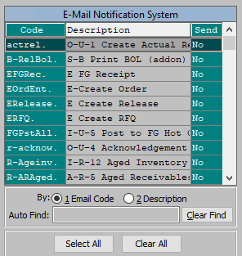

The *‘E-Mail Notification System’* allows the user to quickly choose which e-mails this Contact will receive from the Advantzware system. Contacts will only receive system emails that have their *“Send”* column set to ***“Yes”***.

In order to set the Contact up for a specific email notification, the user can search for their desired Email Code narrow down the browse list, by using the search field located at the bottom of the page.

In order to set a specific contact within the list to a ***“Yes”*** send option, the user must double-click the desired email code. This will set the email send option to ***“Yes”*** if it is currently ***“No”***, opting the Contact in for this specific email. Alternatively, double-clicking an email that currently has a send option of ***“Yes”*** will set it to ***“No”***, thus opting the contact out of receiving the selected email.

#### SELECT ALL

Clicking the ***“Select All”*** button will opt the user into receiving all the system emails currently available, setting all the Send Options to ***“Yes”***.

#### CLEAR ALL

Clicking the ***“Clear All”*** button will opt the user out of receiving all the system emails currently available, setting all the Send Options to ***“No”***.

### Customer Notes – Browse



The *“Contact Notes”* screen allows a user to create an unlimited number of notes pertaining to the currently selected Contact. It keeps track of the note’s date and time so that the user can clean up old notes as necessary.

The *“Browse Notes”* screen shows the user the titles of all of the available notes for the currently selected contact. In order to view detailed notes for a specific contact, the desired note must be selected within the list of all available notes. The user may search for a specific note, or narrow down the browse list, by using the search field located at the bottom of the page.

In order to select a specific note within the list to view detailed information for, the user must ensure that it is highlighted within the list. In order to highlight a note, the user may click on their desired note.

### Customer Notes – View



#### UPDATE

Click the ***“Update”*** button to update the currently selected Contact Note.

#### ADD

Click the ***“Add”*** button to add a new note for the current Contact.

#### COPY

Click the ***“Copy”*** button to copy information from the currently selected Contact Note.

#### DELETE

Click the ***“Delete”*** button to delete the currently selected Contact Note.

#### NEXT

Press ***"N"*** (Next) to find next Contact Note to view or modify. Alternatively, press the ***“Right Arrow”*** on the screen.

#### PREVIOUS

Press ***"P"*** (Previous) to find previous Contact Note to view or modify. Alternatively, press the ***“Left Arrow”*** on the screen.

### Add/Update Notes

#### SAVE

Click the “***Save***” button to save the current Contact Note.

#### RESET

Click the “***Reset***” button to reset all changes to the Contact Note.

#### CANCEL

Click the “***Cancel***” button to cancel the Contact Note without saving changes.

### Add/Update Notes Field Definitions

#### Note Title

The user may enter a short description of this note’s contents in this field.

#### Notes

The user may enter all the notes that they wish in this field.

## Addresses

To view address information for the selected Vendor, the user may now click on the ***“A/Z Pictured Address Book”*** at the top of the screen.

### Browse Address

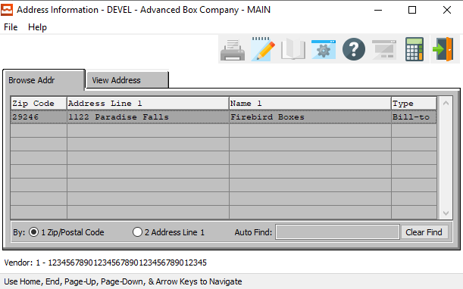

The *“Browse Address”* screen will show the user all of the available addresses for the selected Vendor.

In order to view detailed information for a specific address, the desired address must be selected within the list of all available addresses. The user may search for a specific address, or narrow down the browse list, by using the search field located at the bottom of the page.

In order to select a specific address within the list to view detailed information for, the user must ensure that it is highlighted within the list. In order to highlight a address, the user may click on their desired address.

#### View Address

Once the user has highlighted their desired address to view detailed information for, they may click on the ***“View Address”*** tab at the top of the screen. This tab allows the user to view detailed information, as well as update and add addresses.

### View Address

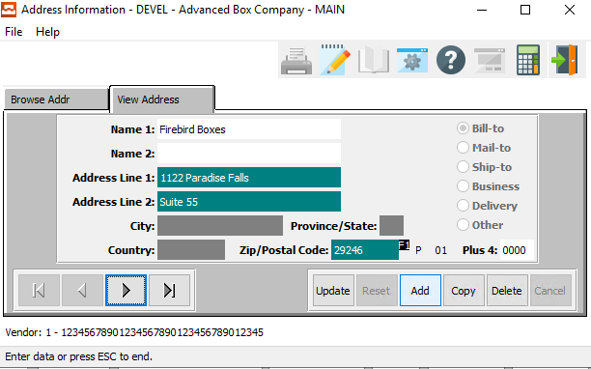

#### UPDATE

Click the ***“Update”*** button to update the currently selected Address.

#### ADD

Click the ***“Add”*** button to add a new note for the current Address.

#### COPY

Click the ***“Copy”*** button to copy information from the currently selected Address.

#### DELETE

Click the ***“Delete”*** button to delete the currently selected Address.

#### NEXT

Press ***"N"*** (Next) to find next Address to view or modify. Alternatively, press the ***“Right Arrow”*** on the screen.

#### PREVIOUS

Press ***"P"*** (Previous) to find previous Address to view or modify. Alternatively, press the ***“Left Arrow”*** on the screen.

### Add/Update Address

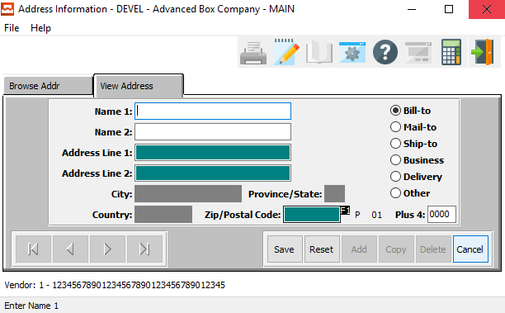

#### SAVE

Click the “***Save***” button to save the current Address.

#### RESET

Click the “***Reset***” button to reset all changes to the Address.

#### CANCEL

Click the “***Cancel***” button to cancel the Address without saving changes.

### Add/Update Address Field Definitions

#### Name 1

The user may enter the initial name for the Vendor at this address.

#### Name 2

The user may enter the secondary name for the Vendor at this address.

#### Address Line 1

The user may enter the initial address line for the Vendor at this address.

#### Address Line 2

The user may enter the secondary address line for the Vendor at this address.

#### Zip/Postal Code

The user may enter the valid zip code for this address. This code must come from the system list of available, valid Zip Codes. Alternatively, the user can press the ***“F1”*** button to choose a code from a list of available Zip/Postal codes.

Once the user has entered or chosen a valid Zip/Postal code, the City, State, and Country will automatically be updated by the system. The user cannot modify these fields here, as they are systematically linked to the valid Zip/Postal Code.

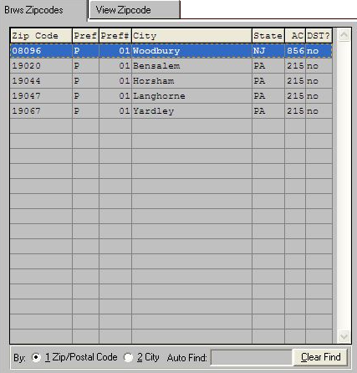

Please Note: If the user does not see their desired Zip/Postal code within this list, they must create a new zip code in the ***“N” – “C” – “6”*** (Zip Codes) system.

#### Plus 4

This field is for the last four digits of the Zip or Postal code.

#### Address Type (Choice)

To choose the preferred Address Type for this address, please make sure the desired option choice bubble is toggled.